**Mr. Visca’s: Calculus (Chpt 3.9)**

**Chpt 3 – Day 16: Derivatives of Exponentials and Logarithms**

**3.9 Derivatives of Exponentials and Logarithms**

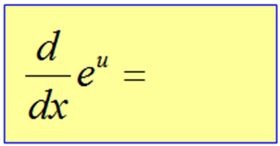

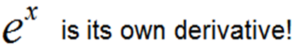

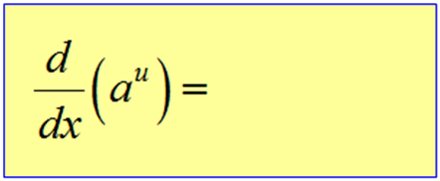

ax - exponential where

variable is the exponent

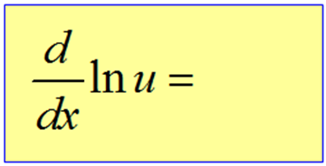

ln x ... natural log function

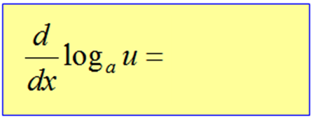

logax ... log function

FYI - for: log x ...

what is the value of a?